Rupesh Kerai 17S01ABT001

CSC 301 – IS Project

M-Soko Manual

Africa Nazarene University

**Table of Contents**

PROBLEM STATEMENT 2

SOLUTION 2

OBJECTIVES 2

CHALLENGES 3

USER SCREEN WALKTHROUGH 4

Sitemap 4

Walkthrough 5

User Screens 6

# PROBLEM STATEMENT

During this day and age where working hours have been cut down by the curfew placed by the government due to the Covid-19 Pandemic. Stores and Shops tend to close the same time as business and those individuals that are working do not get enough time to shop for their day to day food requirements. This is therefore a problem to the working-class individuals working in the business sector who do not have the time to go do their shopping. This affect them as they will have to either take a leave from work to go do necessary shopping for their homes and end up buying high amounts of goods to stock up for a long time, this in turn also leading to a problem to the supermarkets as stores as they will run out of stock quickly.So ideal users of the system would be a customer, supermarket employee and administrator.

# SOLUTION

There for the problem will be overcome by a system designed for the individuals, so that they are able to place orders of their shopping list within minutes from wherever they are and have them delivered to their preferred location. The system will automatically narrow down the preferred location of delivery and provided the closest stores that have the available products that the individual needs, to be able to conquer long delivery timings.

# OBJECTIVES

1. Develop a system that will alow clients to login, select preferred delivery locations and preferred payment methods.
2. The system will allow for customers/clients to make payments online readily available systems after ordering the needed goods.
3. The system will allow for clients to review products and request to return damaged products.
4. The system will allow for users to track their goods from placing order to receiving the goods.
5. The system will allow for administrators to create reports for the increase or decrease in the number of orders over time, and also keep a record of the frequently purchased items.

# CHALLENGES

The challenges that I faced when coming up with the system if firstly to start with is how the design of the page should look like. What appearance should my system have and how it should be designed. The solution I came up for that was to go browse for similar systems as mine and see the looks of them and be able to come up with a similar design.

The next challenge faced was the having to come up with a sign up page and login page as I was not sure on how to work with that, but I researched used resources online to come up with a successful working login and sign up page.

The challenge I faced after that was how give access to pages to users that have signed in and how to restrict users to access pages if they have not signed in, it took a while but I figured how to work with session and was able to complete that.

Moreover, I had fed all my product manually coded to the website to display on the webpage and where it got challenging was when I had to display the product in the cart and checkout page and receive the order the products had to be in a database and I haven’t worked with databases to know how to deal with that, but I used video tutorial and e-learning sites to counter this problem and solve it.

Furthermore, another challenge I faced was creating a cart and checkout page to work with buttons and to a specific user, this took quite a while to figure as there was no specific way to do it as the resources I used had different structure of code compared to mine therefore I had to learn and improve my code accordingly to accomplish that.

# USER SCREEN WALKTHROUGH

## Sitemap

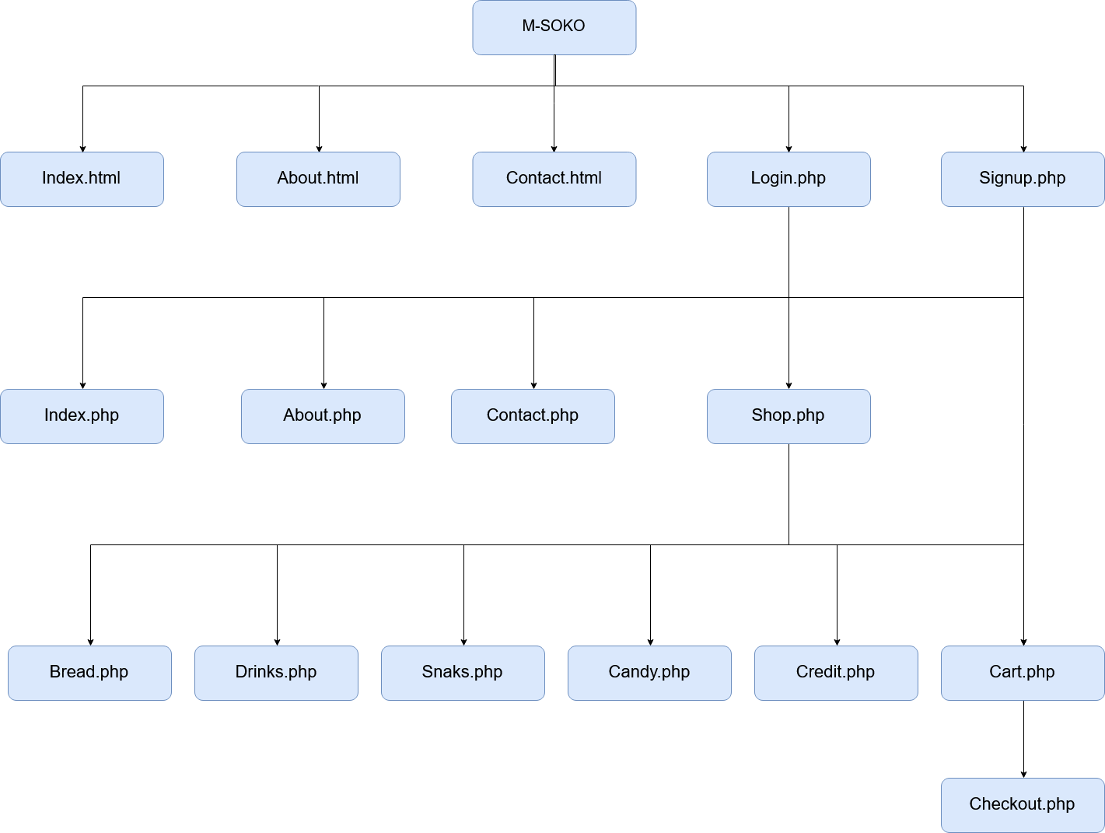

## Walkthrough

Once you enter the site you are taken to the landing page which is index.html which then you can access the pages that are mention above such as about.html, contact.html, login.php and signup.php.

Users can only be able to access the shop and the products after they have logged in. Which includes the filtered pages and the shopping cart which then leads to the checkout page. If a user is not logged in then the shop link will take you to the login or signup page which then a user can make an account to access the shop.

The user’s data is stored in a database where a script I used to give them access to the pages. Once the user logs in a session I created where the username is displayed on the top bar.

Furthermore, the products are stored in a database where they are displayed to the webpage and once the add to cart button is pressed by the user its added to the cart and a summary is shown in the cart page such as the value of the product and the name and the total amount of all products.

Which then there is a link to the checkout page which the user inputs the payments and delivery address and then the order is placed which is the stored in the orders database.

The orders database is then after accessed by the administrator who can access the details on their admin page/dashboard. The admin page also has a summary of the total users, total orders, the products.

The admin can add products to the database and have access to the user’s data which they can delete or edit from the consent of the user. Moreover, the admin can also view the messages from the contact us page which they can reply accordingly.

## User Screens

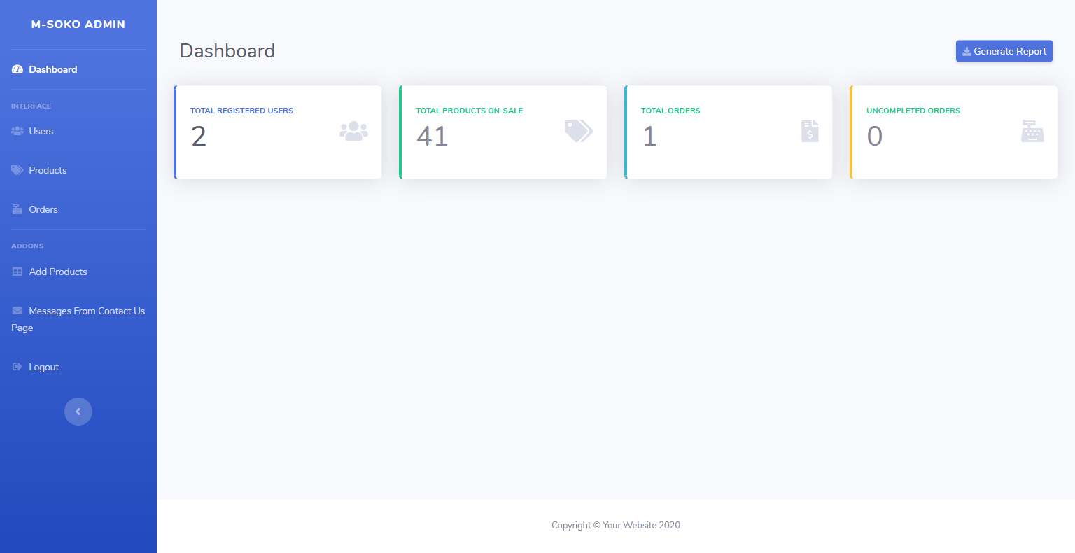

Admin Landing Page

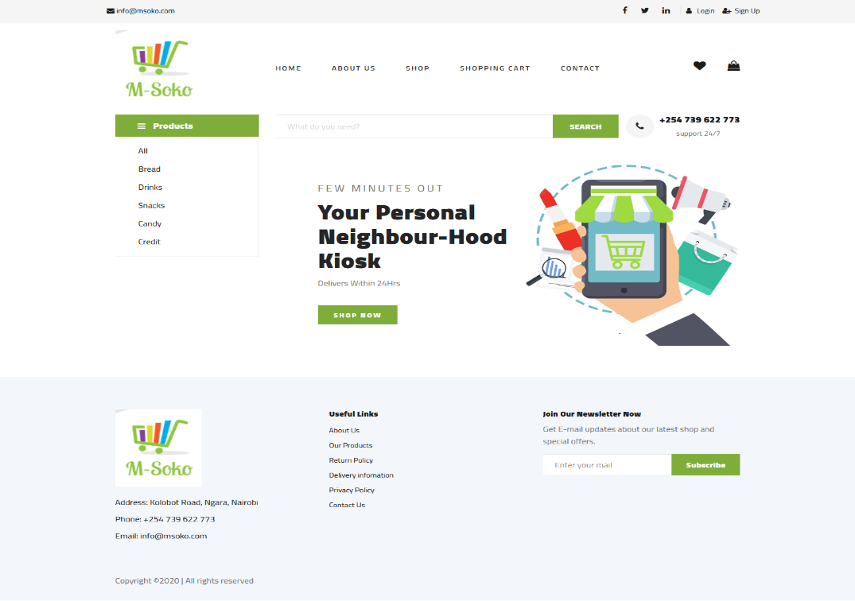

Users Landing Page

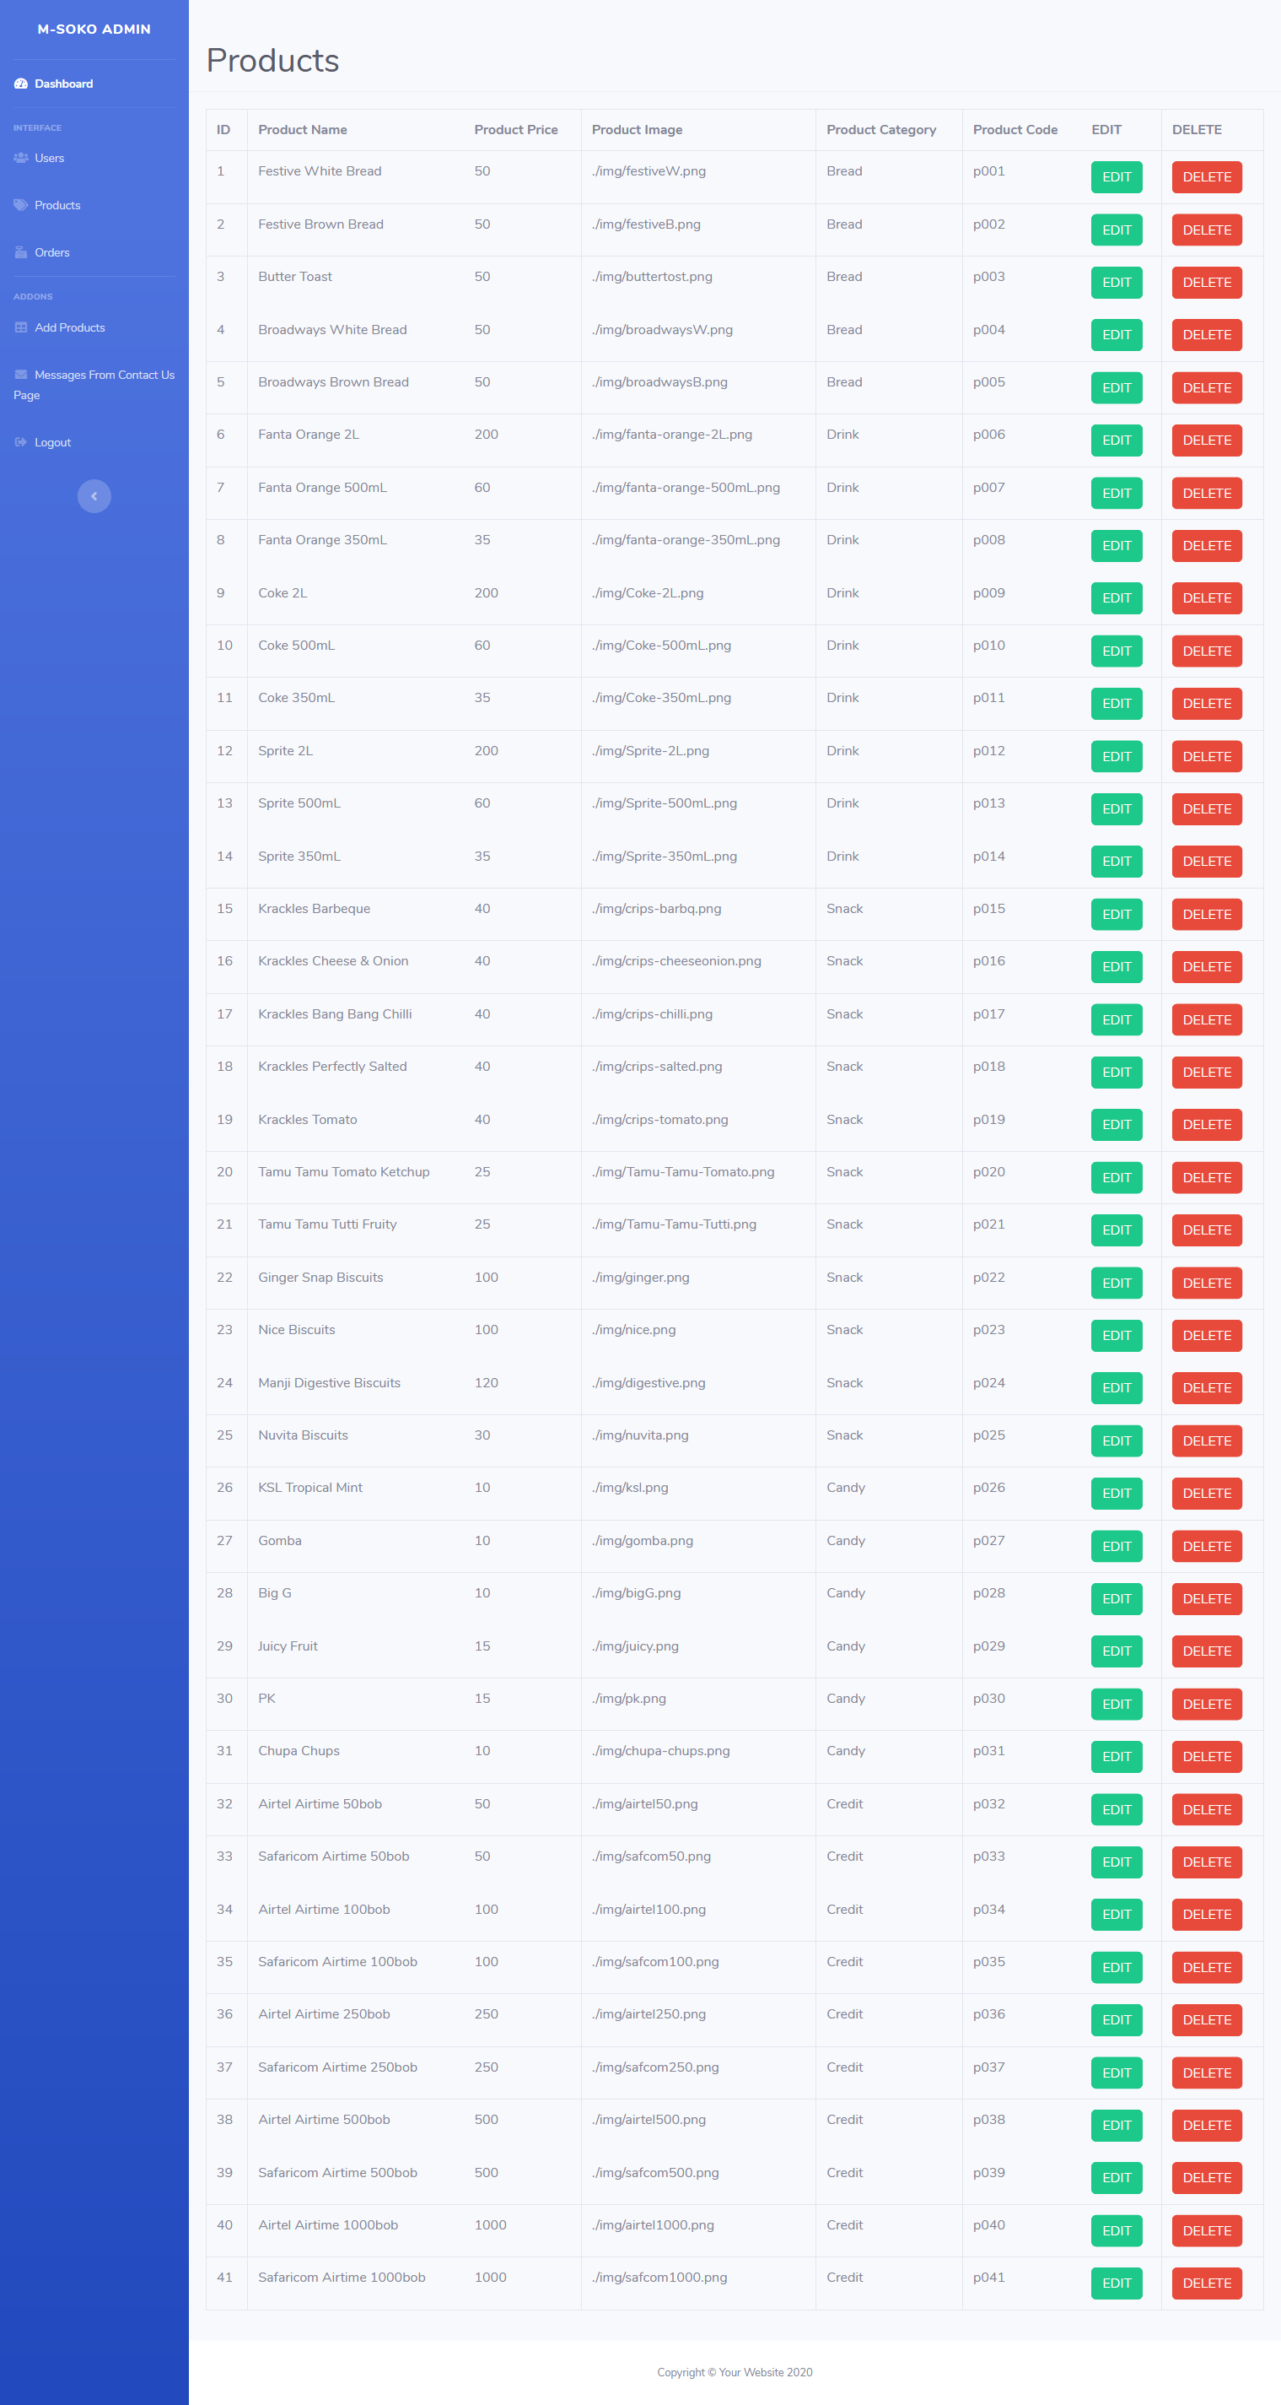

Admin Products Page

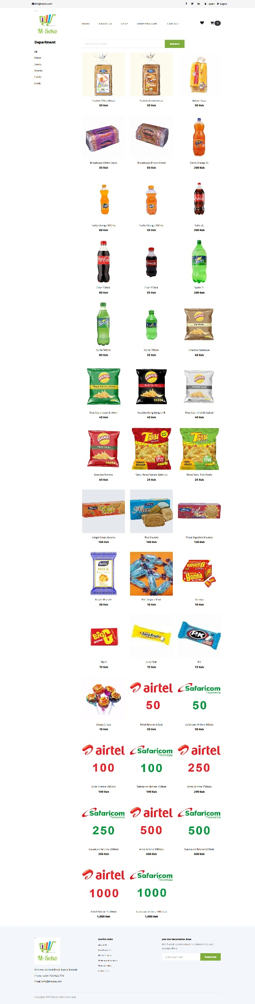

User Shop Page

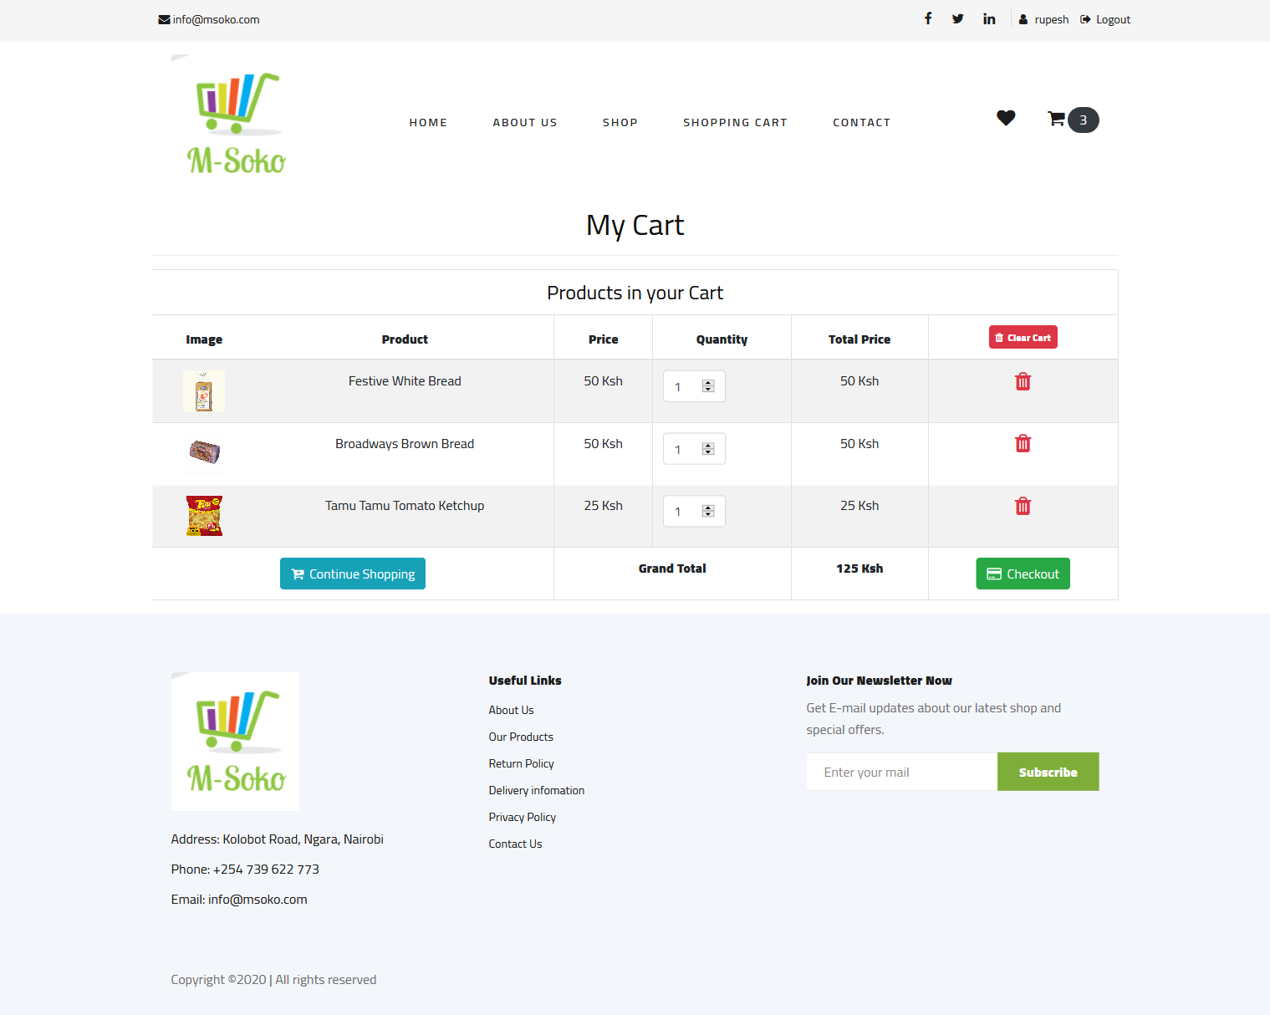

Cart Page

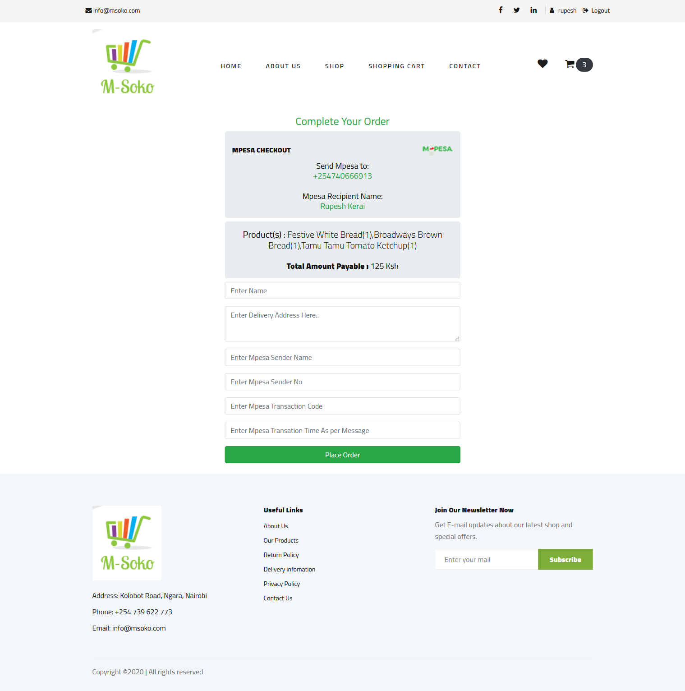

User Checkout Page

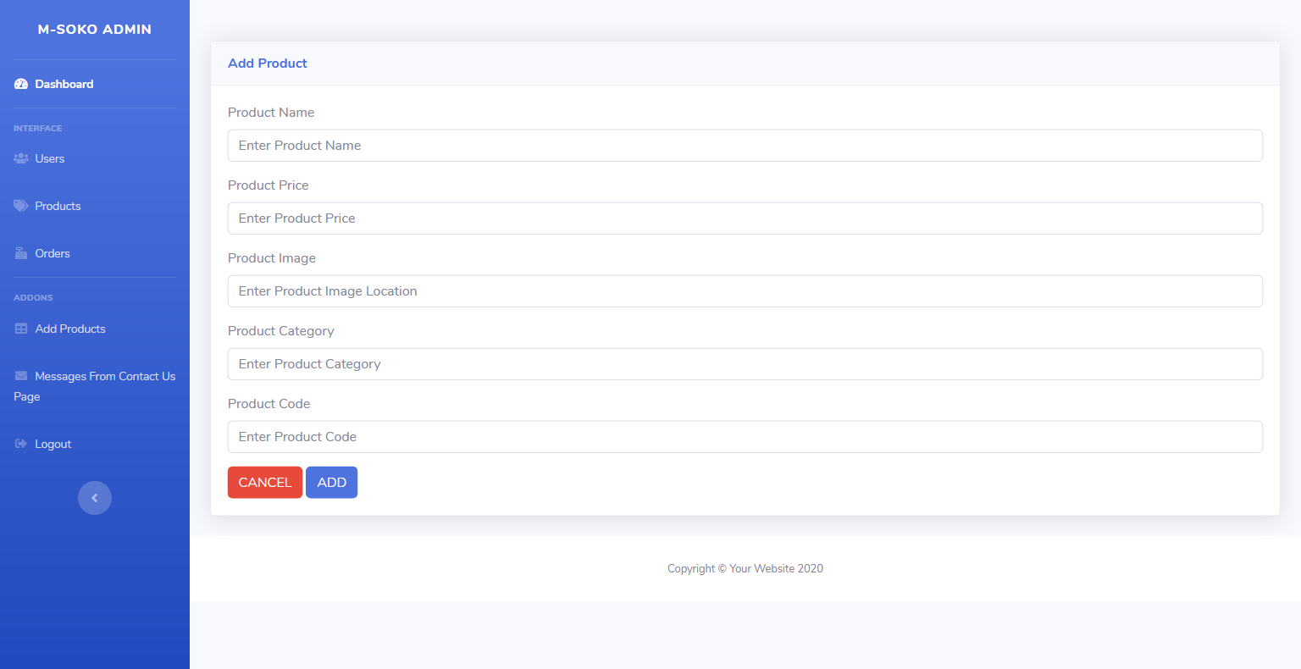

Admin Add Products Page

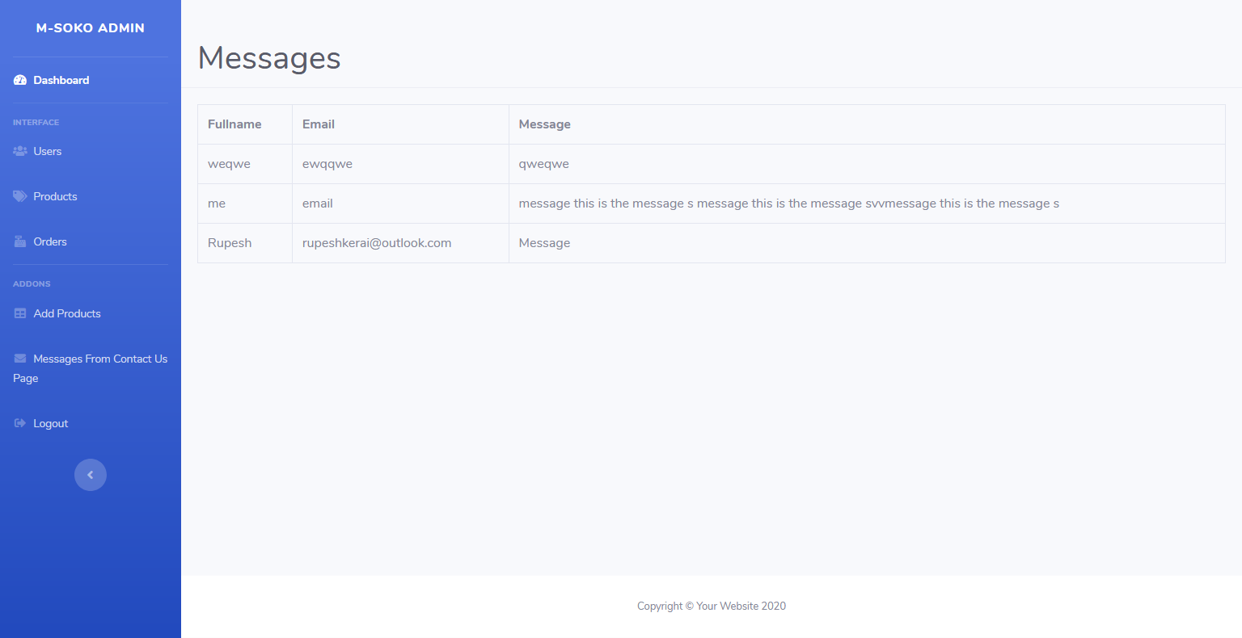

Admin Contact Messages Page

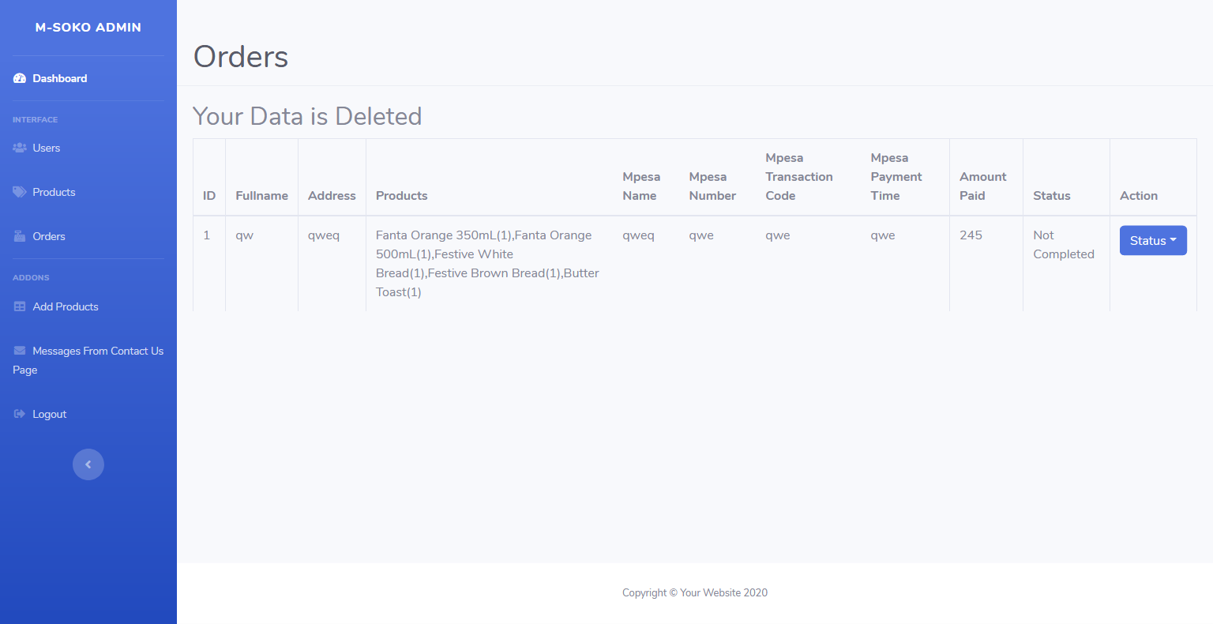

Admin Orders Page